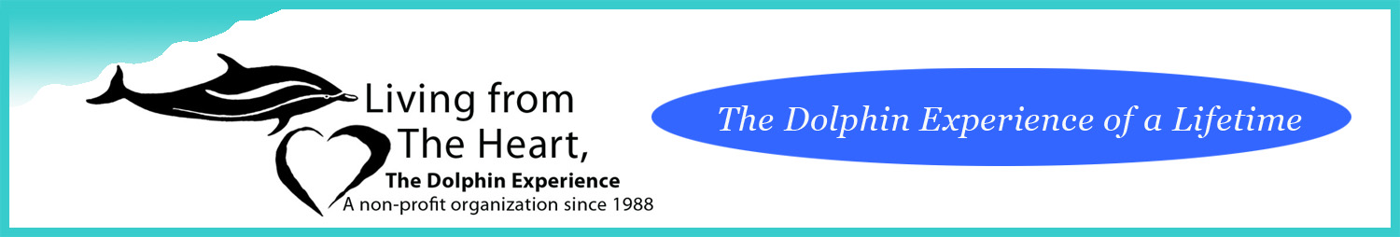
Registration form for Dolphin therapy program
Name:
Age:
Phone number(s) and email:

Information on participant including diagnosis (if any), challenge or illness:

Please tell us about the participant –what they are like as a person –their interests, strengths, challenges?

Number of people in your family or group:
.

How did you learn about Living from the Heart’s dolphin therapy program?

What do you hope to achieve from your dolphin therapy experience with us?

Method of Payment: To pay by check or money order, you may send it to:
Living From The Heart
P. O. Box 865
Morrison, CO 80465
To pay by credit card – will pay with card, call August 2nd to process payment.
Visa or Mastercard (5% processing charge) American Express (10% processing charge)
Name on card:
Card number:
Expiration date:
3 digit code in back:

